


How to promote your group, event or project
for small community groups in Southampton

Southampton City Council Communities Team
This guide has been produced for use by community groups in Southampton who want to promote their projects, activities, events and the groups themselves. Included in this guide is how to write a press release, local media contacts which might be interested in promoting local information and designing a basic poster.
July 2011

INDEX

HOW TO WRITE A PRESS RELEASE

WHO TO CONTACT FOR LOCAL PUBLICITY

HOW TO DESIGN A BASIC POSTER IN WORD

POSTER TEMPLATE

THE AMAZON INTRO TO DEALING WITH THE MEDIA

THE AMAZON INTRO TO MEDIA INTERVIEWS

THE AMAZON INTRO TO PUBLIC RELATIONS

THE AMAZON INTRO TO DEVELOPING CASE STUDIES

HOW TO WRITE A PRESS RELEASE

HEADLINE – make it short and snappy! The best headlines are no more than four or five words

Example: NEW LOOK FOR SCHOOL POND

FIRST PARAGRAPH – summarise your story, including who, what and why? A press release is always more exciting if you start by indicating the people involved rather than inanimate objects or places. Think residents, children or council staff.
Example: Pupils from a Southampton school have teamed up with local businesses to revamp their nature pond.

MAIN BODY OF STORY – go in to more detail about who, what and why and add in the where and when? If the media don’t know when or where your event or project is happening, they can’t plan it into their diary.
Example: The overgrown haven at Greenoak Primary School in Jade Lane, Southampton, will soon be as well presented as when it was first dug thanks to the efforts of Year 4 pupils and employees from Radwell Engineering and DASA supermarket.

The £300 project was inspired by parents and governors who wanted to see the old nature pond spruced up and ready for pupils to explore in the spring.

Next Friday (September 13), the whole school community will gather to see the final weeds cleared and thank the volunteers for their hard work.

OPTIONAL QUOTE – why not include a short and snappy quote from either your project leader or spokesperson. This quote can go anywhere within the article.

Example: Headteacher Richard Simmonds said: “We are indebted to both Radwell Engineering and DASA for the time and funding that they have put into this project. The children had a wonderful time helping them and I know they can’t wait to investigate the pond life next term.”

INFORMATION FOR THE PUBLIC – you may want to give members of the public a contact telephone number, an email address or website where they can go for more information. Make sure the details are correct otherwise someone could receive some unexpected calls!

Example: DASA supermarket has a community fund and is looking for other projects to support. If you would like more information contact their Community Worker Sue Smith on 023 8012 3456 or email sue.smith@dasa.co.uk. Alternatively, you can find out more at www.dasa.co.uk.

THE END – always signal the end of your story with ‘ENDS’ to let the reporter know you have finished writing the information you want them to publish. However, this is not the end of the press release. It’s now time to add photo calls, general facts and contact details.

Example: PHOTO CALL – Reporters and photographers are invited meet pupils and volunteers for a photo call by the finished pond at Greenoak Primary School, Jade Lane, Southampton, at 10am on Friday September 13.

NOTES TO EDITORS – Greenoak Primary School has 150 pupils and is unique as it is Southampton’s only school situated in the middle of an island on the Itchen River. Its most recent Ofsted report said the school had made excellent progress since its last inspection and was now ranked as an ‘outstanding school’. Next year Greenoak Primary will celebrate its centenary.
For more information contact Mr Simmonds on 023 80XX XXXX.

SEND – finally send your press release to local media outlets.

Example of a finished press release:

NEW LOOK FOR SCHOOL POND

Pupils from a Southampton school have teamed up with local businesses to revamp their nature pond.

The overgrown haven at Greenoak Primary School in Jade Lane, Southampton, will soon be as well presented as when it was first dug thanks to the efforts of Year 4 pupils and employees from Radwell Engineering and DASA supermarket.

The £300 project was inspired by parents and governors who wanted to see the old nature pond spruced up and ready for pupils to explore in the spring.

Next Friday (September 13), the whole school community will gather to see the final weeds cleared and thank the volunteers for their hard work.

Headteacher Richard Simmonds said: “We are indebted to both Radwell Engineering and DASA for the time and funding that they have put into this project. The children had a wonderful time helping them and I know they can’t wait to investigate the pond life next term.”

DASA supermarket has a community fund and is looking for other projects to support. If you would like more information contact their Community Worker Sue Smith on 023 80XX XXXX or email xxxxx@xxxx.co.uk. Alternatively, you can find out more at www.xxxx.co.uk.

ENDS

PHOTO CALL – Reporters and photographers are invited meet pupils and volunteers for a photo call by the finished pond at Greenoak Primary School, Jade Lane, Southampton, at 10am on Friday September 13.

NOTES TO EDITORS – Greenoak Primary School has 150 pupils and is unique as it is Southampton’s only school situated in the middle of an island on the Itchen River.

Its most recent Ofsted report said the school had made excellent progress since its last inspection and was now ranked as an ‘outstanding school’.

Next year Greenoak Primary will celebrate its centenary.

For more information contact Mr Simmonds on 023 80XX XXXX.

CONTACTS TO HELP YOU PROMOTE YOUR GROUP, PROJECT OR EVENT

Television
- BBC South Today - email south.today@bbc.co.uk or call 023 8022 6201
- ITV Meridian tonight - meridiantonight@itv.com or call 0844 881 2000

Radio
- Capital South Coast - email online or call 01489 587 650
- BBC Radio Solent – email radiosolentnews@bbc.co.uk (news stories) or solentguide@bbc.co.uk (what's on) or call 023 8063 1311
- Heart Hampshire - email online or call 01489 587 600
- Original 106 (Solent) online via the home page or call 01224 293 800
- The Breeze – email studio@thebreeze.com or call 08454 662 107 (news centre)
- 106 Jack FM – email online or call 08454 661 106 (news centre)
- Wave 105 – email news@wave105.com, add it to the What’s On guide or call 01489 481058 (news desk)
- Unity 101 – email studio@unity101.org or call 02380 235055
- Awaaz FM – email info@awaazfm.com, call 023 8091 5437 or see Facebook www.facebook.com/AwaazFM

Local publications
- Daily Echo - email newsdesk@dailyecho.co.uk or call 023 8042 4522
- Hampshire Chronicle - email news@hampshirechronicle.co.uk or call 01962 860836
- City View (Southampton City Council quarterly magazine for all Southampton homes) city.view@southampton.gov.uk
- Tenants Link (Southampton City Council bi-monthly magazine for tenants) tenants.link@southampton.gov.uk
- Woolston and Itchen Scene (free local magazine delivered to all properties in the area) editor@scene-media.co.uk
- The Communities team weekly email communities@southampton.gov.uk

Local websites
- Bitterne Park (community news for Bitterne Park and nearby areas)
- Portswood (community news for Bitterne Park and nearby areas)
- Daily Echo’s What’s On Guide
- Southampton City Council’s What’s On Guide

Local social media
- Facebook “Southampton’s Communities”
- Facebook “Free Southampton”
- Facebook “I Love Sholing”
- Facebook “Freemantle and Shirley Community Friends”
- Facebook “Bevois Valley”
- Facebook “Green Hampshire”
- Facebook “Southampton’s Green Living Room”

- Twitter – direct message @Southamptonscom, @sccevents, @soton_events and we can retweet your event messages.

Southampton universities contacts
- Southampton University student union communications contact - vpcomms@susu.org
- Southampton Solent University student union communications contact – sucommunications@solent.ac.uk
If you are aware of any other ways to advertise locally please contact sam.bennett@southampton.gov.uk as we are also always looking for new outlets to let people know what’s happening where they live.

HOW TO DESIGN A BASIC MEETING POSTER

- Add background image, centre and send behind text
- Add text box for title of the meeting, include title, what the meeting will discuss and if its open to anyone
- You can alter the size and type of font. And ‘fill’ the text box with colour or ‘no fill’ will show the background image. You can also add borders to the box if you want more impact.
- A second text box can be used to tell people the groups aim, message or tag line.
- Another text box can provide more detail about the meeting to get people’s interest.
- The main focus of the poster should the what, where and when, add a large box with large text to give the date, time and venue of the meeting
- Add an image which shows your group or the work you do
- Make sure you put contact details on the poster so if anyone has any questions they can speak to someone
- Add any other message you’d like to get across in a text box

Tips:
  - Less is more, try to write concisely and not have too much clutter on the page ie outlines, pictures.
  - Bigger, simple type i.e. Arial, Verdana or Tahoma is easier to read
  - Black on white or yellow is best for people with sight impairments as there is a good contrast
  - Red and black, and blue and green together are difficult to read
  - When designing in colour check how it looks if you have to print in black and white to reduce costs before printing 100s of copies
  - If you add on personal details you may not want to put your home phone number on the poster but a group mobile or email

POSTER TEMPLATE IS ON THE FOLLOWING PAGE

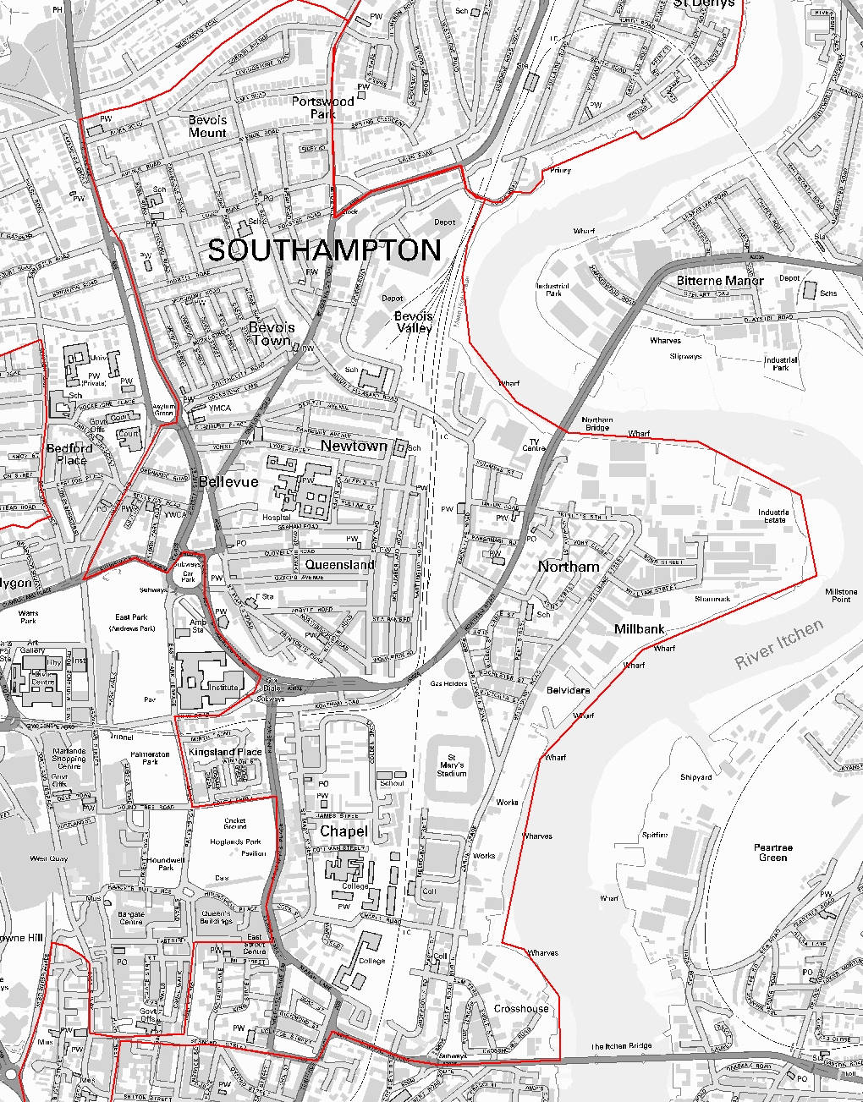
MONDAY 1st AUGUST

7.00PM

NEWTOWN YOUTH CENTRE, GRAHAM ROAD
If you have a couple of hours spare a month come along and join the committee and help make the area a better and safer place to live.

For more information please contact Malkeat Singh 023 8083 3197.
Newtown Residents Association
Annual General Meeting
COME ALONG AND FIND OUT WHAT THE GROUP HAS ALREADY ACHIEVED AND HOW YOU CAN BECOME INVOLVED TOO
HELP US MAKE A DIFFERENCE

This written information is available on request in other formats or languages. Please contact tel 023 8083 3445 or email communities@southampton.gov.uk for help.


www.southampton.gov.uk/yourcommunity

Designed and produced by Southampton City Council 06.11.23081

