GOOD HANDLING TECHNIQUE
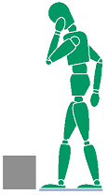

STOP AND THINK
Check the object and plan the lift
Consider using mechanical assistance
Break the load down if possible
Get help if required
Make sure you can see where you are going
Be aware of uneven floor surfaces
Avoid twisting, stooping and overstretching

ADOPT A GOOD POSTURE STAND CLOSE TO THE LOAD AND PLACE YOUR FEET

Feet spread to shoulder width for greater stability
Lead foot slightly forward
Keep your chin tucked in
If load has sharp edges, wear protective gloves
When lifting a load from the floor, it is better to slightly bend your back,
hips and knees

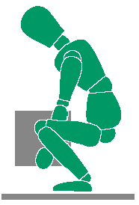
GET A GOOD FIRM GRIP, LIFT WITH YOUR LEGS AND NOT YOUR BACK
Maintain your backs natural line
Don’t kneel or bend the knees fully as this reduces leg power
Raise your chin as you begin to lift
Raise your head and shoulders first, and then use your powerful leg muscles to push your body up slowly, in smooth action
Lift smoothly; keeping control over the load



KEEP THE LOAD CLOSE TO THE BODY
Shoulders and hips should face the same direction
Feet should point in the direction of the move
Keep the load close, with the heaviest side next to the trunk
Move feet to change direction

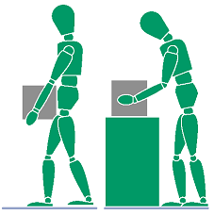

PUT DOWN, THEN ADJUST
If precise positioning is necessary, put it down first

