
School Advice Note

Health and Safety Law
What You Should Know Poster

- Schools are required under Health and Safety legislation to display the Health and Safety Law poster.

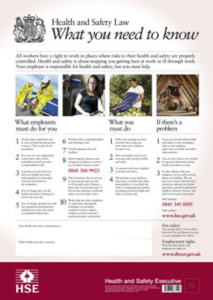
- The poster reflects changes in the law to reduce the administrative cost to employers of having to provide additional written information on the poster and having to keep this information up to date. Instead, employees are advised to phone the HSE Infoline to be put in touch with the health and safety enforcing authority for their workplace or with HSE for employment medical advice.

- There are boxes where details of any employee health and safety representatives and other health and safety contacts can be added.

The poster is available from the HSE Book store

