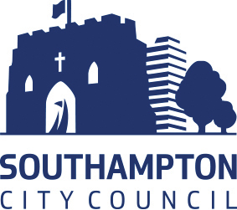
School Advice Note
Inflatable Bouncing Devices

- The Health and Safety Executive has published guidance covering Bouncy castles and other play inflatables: safety advice (see link below). These items may be hired by schools for indoor and outdoor use. This note describes various factors that can contribute to accidents involving inflatable bouncers and the precautions that should be taken to avoid them.

- Inflatable bouncers are amusement devices that are manufactured from flexible fabric and the structure is inflated by one or more blowers, which are connected to the structure.

- There are three main types. They are:

  - Open-sided, known as flat beds;
  - Open-fronted, known as castles;
  - Totally enclosed;

- Safe Working Procedure – Safe Working Procedure Play Equipment outlines the following:

  - Main hazards that can be encountered when using these devices;
  - The safe operation both indoors and outdoors;
  - The selection of bouncers;
  - Training required for attendants;
  - Examination, inspection and maintenance;

- References

  - Southampton City Council Safe Working Procedure – Play Equipment.
  - Bouncy castles and other play inflatables: safety advice (hse.gov.uk)

