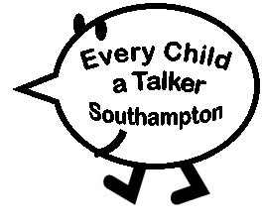
Exploring a new Book from a child’s perspective
Select a book you are not familiar with. You are going to explore this book in the way a child might do – using your ideas and individual ideas/experiences rather than the story.

- DO NOT read the text – you are a young child!
- Flick through the book – you may not start at the beginning (or even hold it the right way up)
- Can you tell what the story is about from the pictures?
- Pick out a page that you feel would hold a child’s interest
- Answer the following questions with your partner.

What particularly interests you on the page?

Is there anything funny, exciting or surprising on the page?

Is there anything scary or negative on the page?

Is there anything that reminds you of your own home or experiences?

What would you like to know or ask about? (i.e. a question or comment that a young child might say)

Can you think of a response to the last question that a less skilled practitioner would say?

Can you think of a more appropriate response that would develop a child’s communication skills?

